// Assignment no-5(2)

// Name- Prerana Rajesh Gajare Class-SEIT RollNo-SI41

/\*PROBLEM STATEMENT: -

5. Write an Embedded C menu driven program for :

ii) Divide 8-bit number by 8-bit number

\*/

//Source Code: -

#include <xc.h>

#include <stdio.h>

#include <stdlib.h>

#include <pic18f4550.h>

void main (void)

{

int a, b, count;

a=18;

b=3;

count=0;

while(a>=b)

{

a=a-b;

count++;

}

TRISD=0;

PORTD=count;

return;

}

\*\*\*\*\*\*\*\*\*\*\*\*\*\*\*\*\*\*\*\*\*\*\*\*\*\*\*\*\*\*\*\*\*\*\*\*\*OUTPUT\*\*\*\*\*\*\*\*\*\*\*\*\*\*\*\*\*\*\*\*\*\*\*\*\*\*\*\*\*\*\*\*\*\*\*\*\*\*

1)I/O VIEW

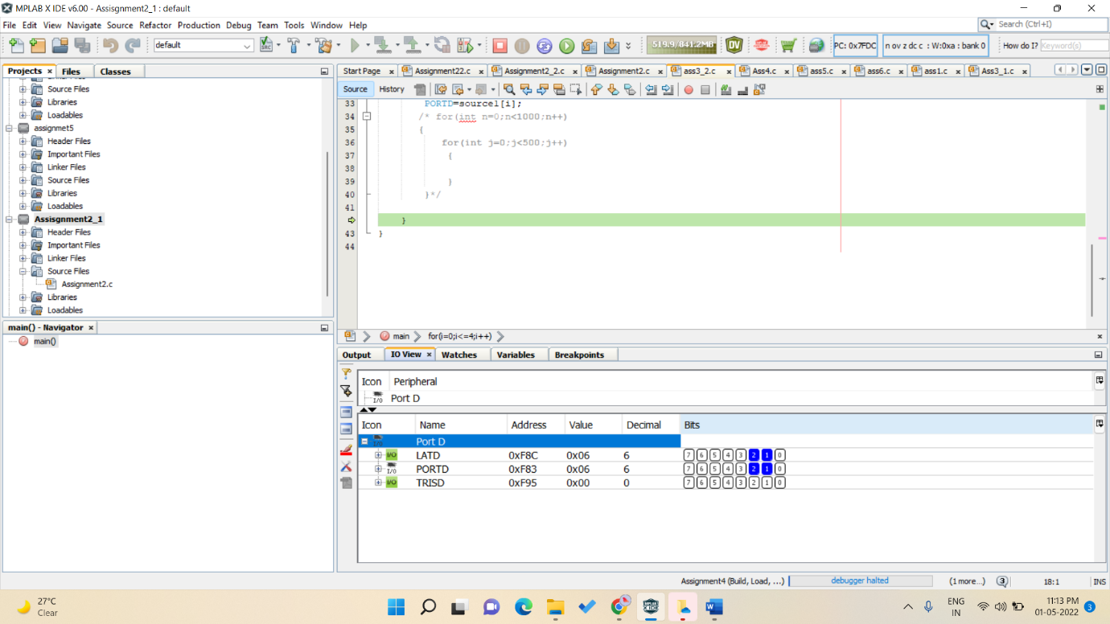

2) PICSIMLAB OUTPUT

